Crashing and Recovering: Fail-Fast Resilience Experiment

Introduction
In this experiment, I simulated a downstream dependency failure inside my ECS-hosted product search API and evaluated how the system behaved under load. The goal was to demonstrate how a poorly handled dependency can degrade system performance, and how implementing a fail-fast timeout improves resilience and throughput.
The system is deployed using:
- Amazon ECS (Fargate)
- Application Load Balancer (ALB)
- Auto Scaling enabled
- CloudWatch for monitoring
- Locust for load testing
The /products/search endpoint was modified to simulate a slow downstream dependency.

Problematic Deployment (Broken Version)

2.1 Simulated Failure
I introduced a fake downstream service inside the /products/search handler:
func fakeExternalService() error {
if rand.Intn(100) < 30 {
time.Sleep(2 * time.Second)
return errors.New("downstream timeout (simulated)")
}

time.Sleep(10 * time.Millisecond)
return nil
}
In this configuration:
- 30% of requests sleep for 2 seconds
- The API waits the full duration
- This causes request blocking and queue buildup under load

2.2 Load Test Configuration
- 1000 concurrent users
- 100 requests per second
- 3–5 minute test duration
- Traffic routed through ALB
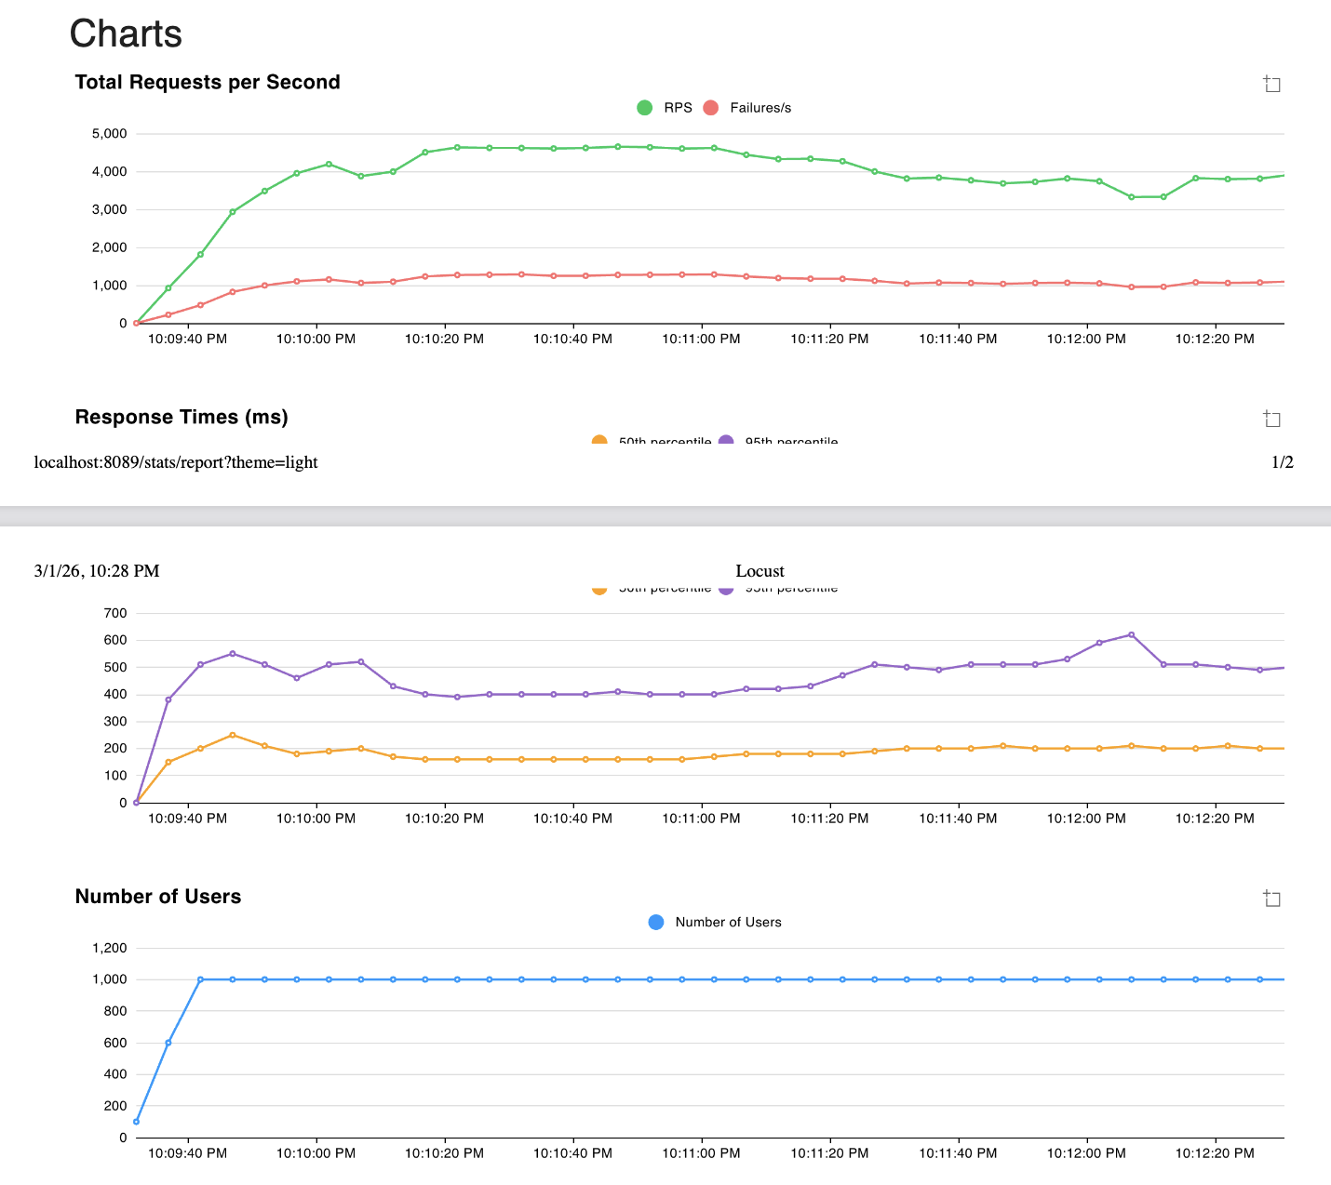

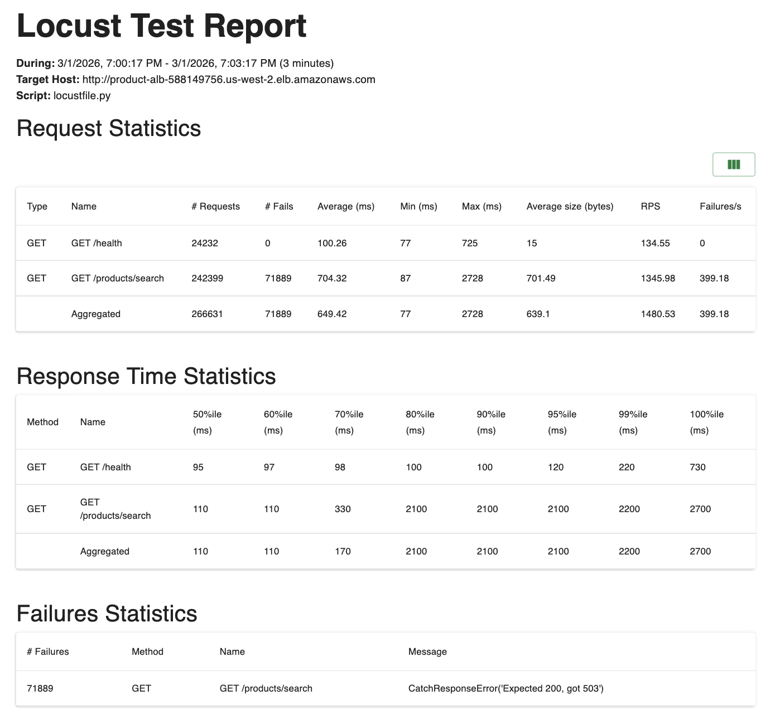
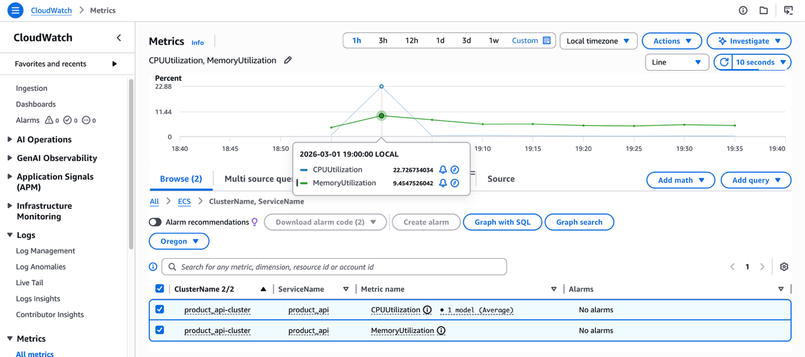

2.3 Observed Behavior (Broken)
Under load, the system exhibited:
- Aggregated RPS: ~1480 RPS
- High response times due to 2-second blocking
- Increased request queuing
- Controlled 503 errors
- Moderate CPU utilization
Even though CPU was not fully saturated, throughput was significantly limited because requests were blocked waiting on the slow dependency.
This demonstrates a classic cascading latency problem in distributed systems.

3. Implemented Fix: Fail-Fast Timeout
To improve resilience, I wrapped the dependency call with a timeout:
func fakeExternalServiceWithTimeout(timeout time.Duration) error {
done := make(chan error, 1)

go func() {
done <- fakeExternalService()
}()

select {
case err := <-done:
return err
case <-time.After(timeout):
return errors.New("dependency timed out fast (fail-fast)")
}
}

// var depErr = fakeExternalService()
var depErr = fakeExternalServiceWithTimeout(200 * time.Millisecond)
if depErr != nil {
// Controlled failure: we return fast instead of hanging
c.JSON(http.StatusServiceUnavailable, gin.H{
"error": "dependency failed",
"detail": depErr.Error(),
})
return
}

Instead of waiting 2 seconds, the system now:
- Stops waiting after 200ms
- Returns 503 immediately
- Frees worker capacity
- Prevents request pile-up
This implements the Fail-Fast resilience pattern.

4. Improved Deployment (Fixed Version)

4.1 Load Test Configuration (Same as Before)
- 1000 users
- 100 req/s
- Same duration
- Same infrastructure
- Only code behavior changed
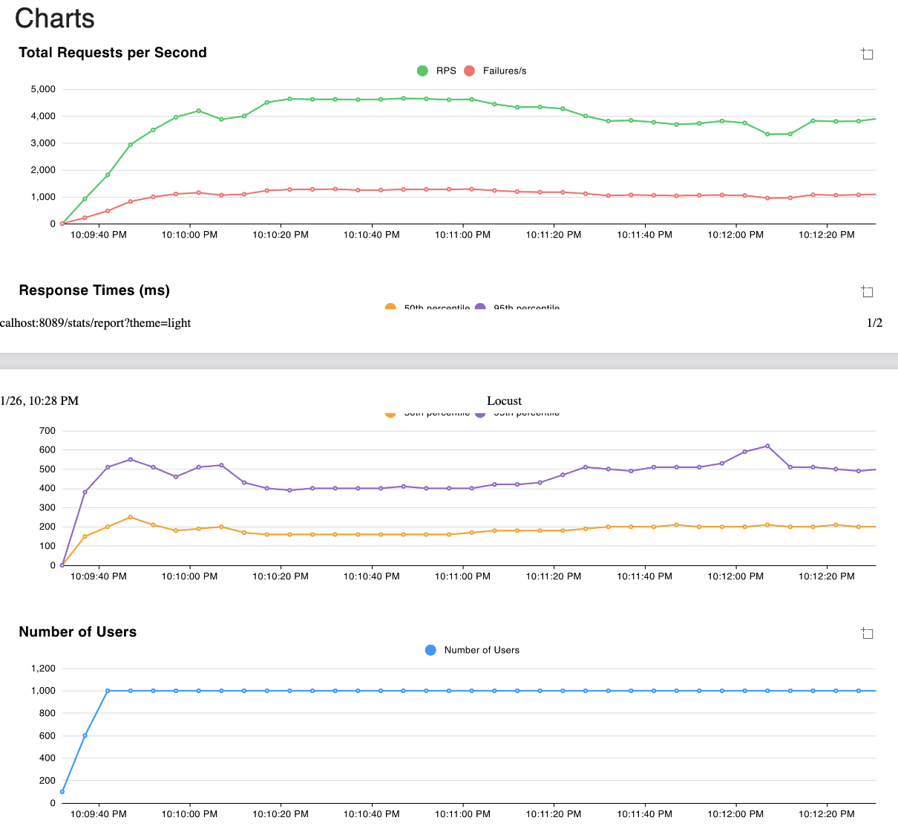
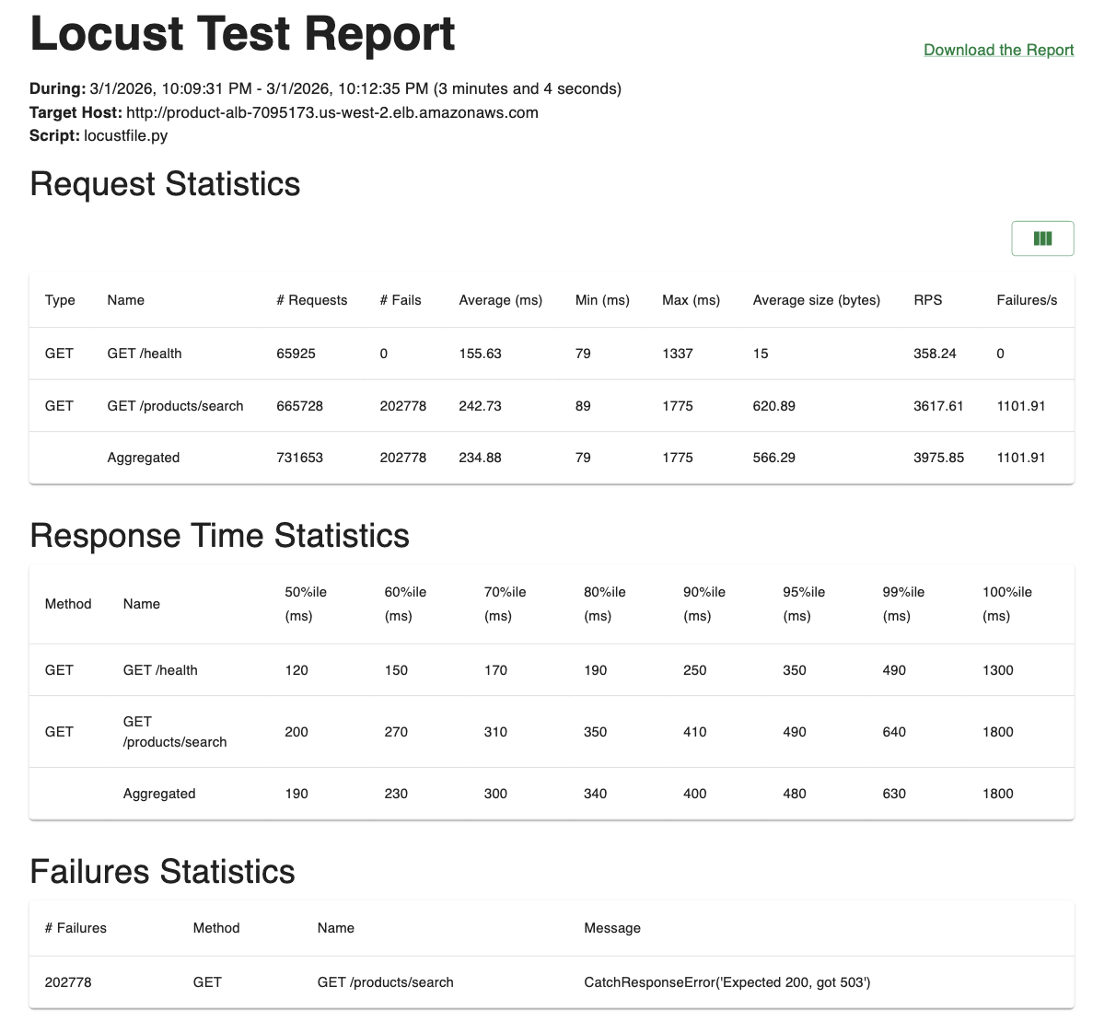
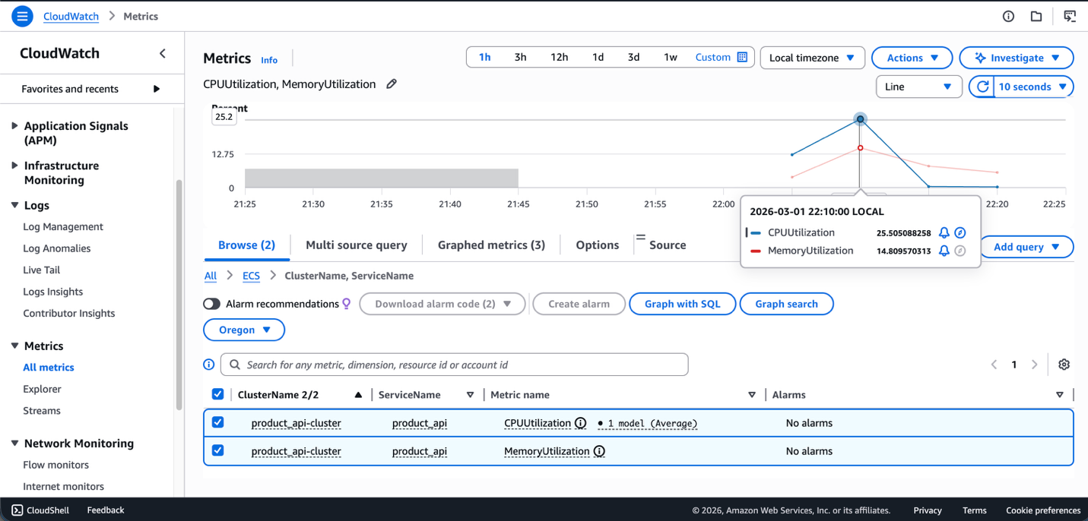

4.2 Observed Behavior (Fixed)
Under identical load conditions:
- Aggregated RPS increased from ~1480 -> ~3975
- Response times significantly improved
- Throughput stabilized
- CPU slightly increased (~25%) due to higher throughput
- Failures remained controlled and predictable (503)
The increase in CPU utilization reflects improved throughput and system activity, not instability.

5. Before vs After Comparison
Metric | Broken | Fixed
RPS | ~1480 | ~3975
Dependency Wait | 2 seconds | 200ms
Latency | High / Blocking | Bounded
Throughput | Limited | Scaled
Failure Type | Slow degradation | Fast controlled failure

The fixed system demonstrates graceful degradation instead of cascading slowdown.

6. Conclusion
This experiment demonstrates how improper handling of downstream slowness can significantly reduce system throughput without necessarily saturating CPU resources.
By implementing a fail-fast timeout:
- Request blocking was eliminated
- Throughput nearly tripled
- Latency stabilized
- The system became more resilient under load
This validates the importance of resilience patterns such as Fail Fast in distributed systems.
The experiment successfully demonstrated:
- A problematic deployment
- A resilience-based fix
- Measurable improvement through controlled testing
- Use of CloudWatch metrics to evaluate system behavior

